FUNDAMENTALS OF MACHINE LEARNING FINAL PROJECT

CREDIT CARD FRAUD DETECTION

INTRODUCTION:
Credit card fraud is one of the most common and costly financial crimes in today’s world. As people shifted to cashless payments and online shopping the number of fraudulent transactions has been increased. According to the Federal Trade Commission (FTC), credit card fraud accounts for billions of dollars in losses every year, affecting both banks and individual customers.
With millions of transactions every day, detecting these fraudulent credit card transactions manually is impossible. This is where machine learning plays a vital role. Instead of a human checking each transaction, we can build a model that automatically looks at the transaction details and decides whether it looks suspicious or not. By training a model on historical transaction data, banks can automatically flag suspicious transactions in real time, reducing financial losses and protecting customers.

PROJECT GOAL:
The main purpose of the project is to build a model that can identify whether a credit card transaction is fraud or legitimate. By applying machine learning techniques, we can automate the detection of suspicious transactions in real time, which helps banks protect their customers and reduces the need for manual review. The model is built based on historical transactions to detect the fraudulent transactions. This kind of model is very useful for any financial institution that wants to improve its fraud detection process without relying on human judgment alone.
This kind of model is useful not just for fraud detection but also for risk management. Banks can use the fraud probability scores generated by the model to decide which transactions need further review and which ones can be processed normally. This reduces the workload on fraud analysts and speeds up the decision-making process.

OVERVIEW OF THE DATA:
The data used in the analysis was taken from Kaggle.com. It is called the Credit Card Transactions Fraud Detection Dataset, and it contains real credit card transaction records from 983 unique customers across 693 merchants over a period of approximately 18 months, from January 2019 to June 2020. The full dataset has 1,296,675 transactions and 22 columns. Since this is a very large dataset, we took a random sample of 10,000 transactions to work with in R due to the computational limitations. Even though we are working with a sample, it still maintains the same distribution and patterns as the full dataset. Out of the 22 variables available, we selected 5 that are most relevant for detecting fraud.The others, like cardholder name, street address, and transaction ID, are just identifiers that don't tell us anything useful about whether a transaction is fraud or not, so we removed them to avoid adding noise to the model.

Independent Variables:
amt — Transaction amount in dollars
gender — Gender of the cardholder (Male or Female)
category — Type of merchant where the transaction happened
city_pop — Population of the city where the transaction took place

Dependent Variable:
is_fraud — Whether the transaction is fraud (1) or legitimate (0)

DESCRIPTIVE ANALYSIS:
A summary of data is taken to understand the distribution of each variable. The most important observation was that only 59 out of 10,000 transactions (0.59%) were fraudulent. This means the dataset is highly imbalanced, which is very realistic for fraud data because most transactions in real life are legitimate.

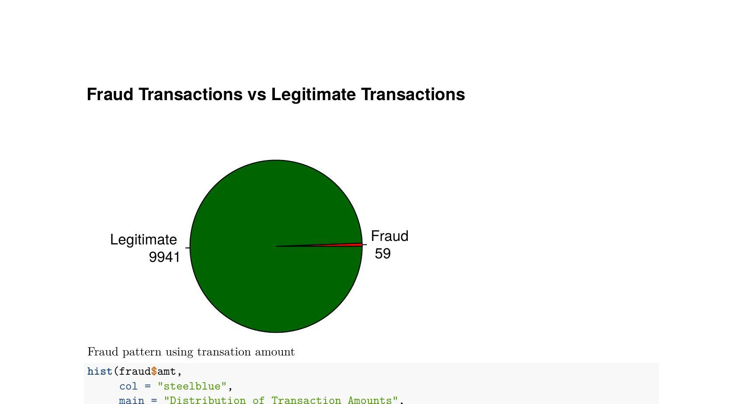
We also looked at the distribution of transaction amounts using a histogram. Most transactions were for small amounts, typically under $200, which makes sense since everyday purchases like groceries and gas are usually low in value. Very few transactions exceeded $500.

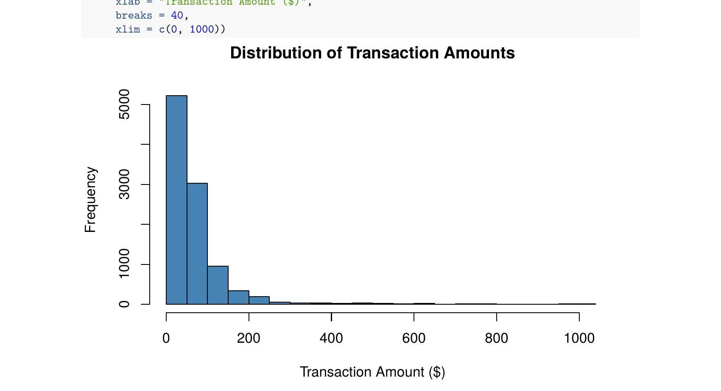

DATA TRANSFORMATION AND NORMALIZATION:
All the required variables are converted to numbers as the machine learning model can only work with numbers. This process is called data transformation. The gender column was changed to binary (Male = 1, Female = 0) and the category column was converted from text labels to numeric values using as.factor() and as.numeric() in R. We also converted the is_fraud column to a factor so that R would treat it as a classification variable and not a continuous number.

After the transformation, we normalized the transaction amount (amt) column to a scale between 0 and 1. This is important for KNN because it calculates the distance between data points, and if one variable has a very large range, it will dominate the model and give wrong results. Normalization puts everything on the same scale so that no single variable unfairly dominates the model.

FEATURE SELECTION:
A correlation matrix is plotted to see how independent variables relate to the target variable. From the matrix, we can see that transaction amount has the highest correlation with fraud (0.308), which means higher transaction amounts are more likely to be fraudulent. The other variables like gender, category, and city population had much weaker correlations with fraud (Gender had a very weak correlation of 0.011, category had 0.030, and city population had 0.006), but we kept them in the model since they still contribute some predictive value.

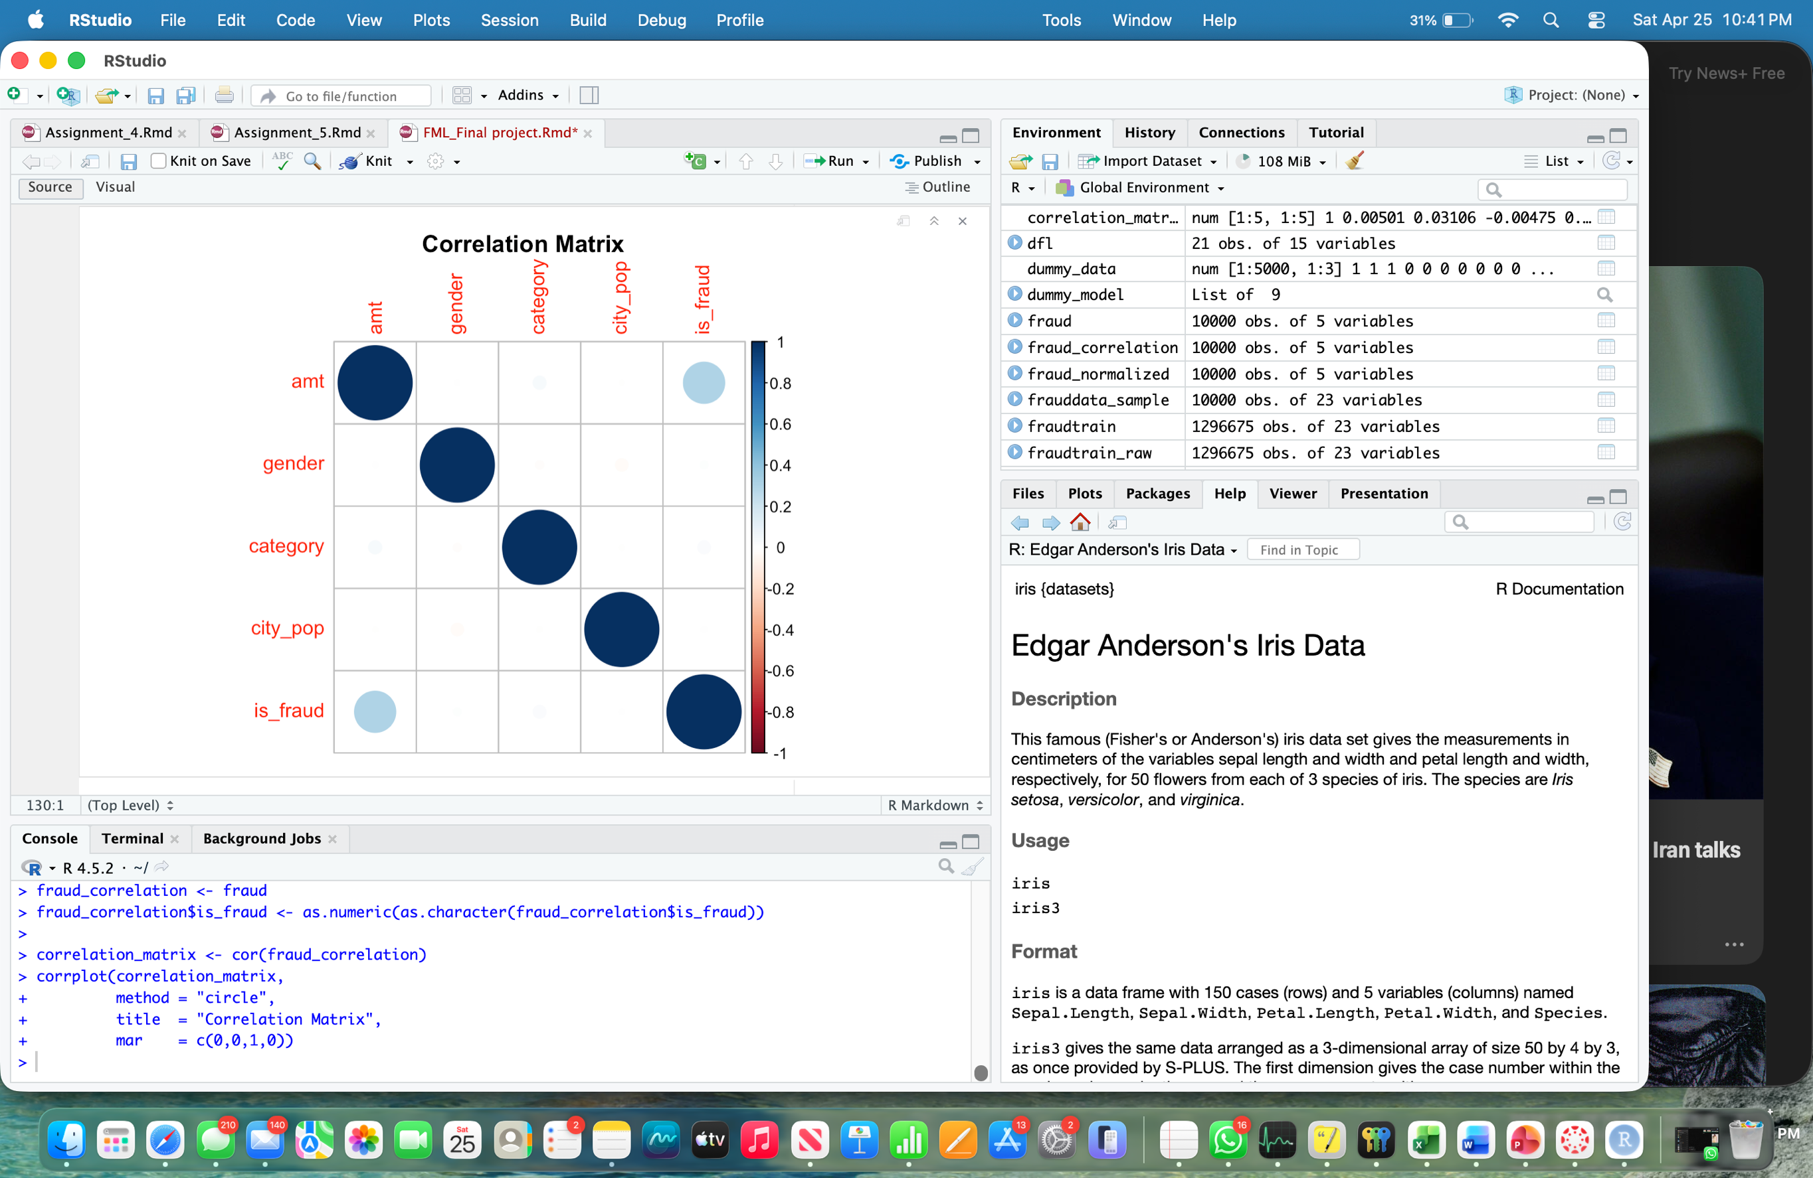
MODEL DEVELOPMENT:
The objective of this project is to classify each transaction as either fraudulent or legitimate using two machine learning algorithms: K-Nearest Neighbor (KNN) and Naive Bayes. Both are supervised classification algorithms. The data was split into 70% for training and 30% for testing. The training set is what the model learns from — it sees both the transaction details and whether each one was fraud or not. The testing set is used afterward to evaluate the model on data it has never seen before. This is important because it gives us a realistic measure of how well the model would perform in real life.

K-Nearest Neighbor (KNN) Model:
KNN is a simple but effective classification algorithm. The way it works is that when a new transaction comes in, the model looks at the K most similar transactions in the training data and checks what class they belong to. If most of the K nearest neighbors are fraud, it classifies the new transaction as fraud. If most are legitimate, it classifies it as legitimate.
For the KNN model, we first needed to find the best value of K. We tested K values from 1 to 10 and calculated the accuracy for each one. K=6 gave the highest accuracy and was selected as the optimal hyperparameter for our model.
However, when we ran KNN on the original 10,000 transaction dataset, the model predicted every single transaction as legitimate and completely failed to detect any fraud. This happened because of the severe class imbalance — with only 59 fraud cases out of 10,000, the model just learned to always predict the majority class. It couldn’t recognize the fraud transactions because the data has very few of them.
To fix this, we created a balanced dataset by taking all 59 fraud transactions and randomly sampling 100 legitimate transactions. After running KNN on this balanced dataset, the model was able to detect some fraud cases, as shown in the confusion matrix below.

 | Predicted Legitimate | Predicted Fraud | Total
Actual Legitimate | 23 | 7 | 30
Actual Fraud | 12 | 5 | 17

KNN model was able to correctly identify 5 out of 17 fraud cases in the test set, giving a sensitivity of 29.41%. The overall accuracy was 59.57% and the specificity was 76.67%. The low sensitivity shows that KNN still struggled to detect fraud even after balancing, which is a known limitation of KNN when dealing with rare events.

NAÏVE BAYES MODEL:
As a result of the unsatisfied results of KNN model, the Naïve Bayes model was built to classify the transactions as fraud or legitimate. Naive Bayes works by calculating the probability of each class for a given transaction, assuming that all features are independent of each other. The Naïve Bayes is built on 10,000 transactions data set without balancing the data unlike the KNN model, as Naïve Bayes approach does not rely on distance calculations.
The model also provides a probability score for each transaction, which tells us how likely a transaction is to be fraudulent. This is very useful for banks because they can set a threshold and flag any transaction above a certain probability for further review.
For example, it might say "this transaction has a 94% probability of being fraud." Banks can use these scores to set their own thresholds — for example, flagging anything above 70% probability for manual review. This makes the model much more flexible and practical for real-world use.

 | Predicted Legitimate | Predicted Fraud | Total
Actual Legitimate | 2934 | 48 | 2982
Actual Fraud | 8 | 9 | 17

Naive Bayes model achieved an accuracy of 98.13% and a sensitivity of 52.94%, successfully identifying 9 out of 17 fraud cases in the test set. This is significantly better than KNN, especially in terms of sensitivity. The specificity was 98.39%, meaning the model also did a very good job of correctly classifying legitimate transactions.

KEY INSIGHTS:

- From the analysis it is observed that, the transaction amount is the most significant predictor of fraud, with a correlation of 0.308 with the target variable. This observation suggests that unusually high transaction amounts are a strong indicator of fraudulent activity.

- The class imbalance in the dataset was a major challenge, particularly for KNN, which required under sampling to detect any fraud at all. Naive Bayes handled the imbalance much better without needing any modification to the data.

- KNN model showed limitations in detecting fraud due to class imbalance, even after balancing the dataset. In contrast, Naive Bayes performed significantly better across all metrics, particularly sensitivity and AUC, making it the more reliable model for this problem.

Model | Accuracy | Sensitivity | Specificity | AUC
KNN | 59.57% | 29.41% | 76.67% | 0.530
Naive Bayes | 98.13% | 52.94% | 98.39% | 0.877

- The ROC curve below gives us a visual comparison of both models. The red curve (Naive Bayes) is clearly closer to the top-left corner, which means it is better at distinguishing between fraud and legitimate transactions. The AUC (Area Under the Curve) for Naive Bayes is 0.877, while KNN only achieved 0.530 — barely better than random guessing.

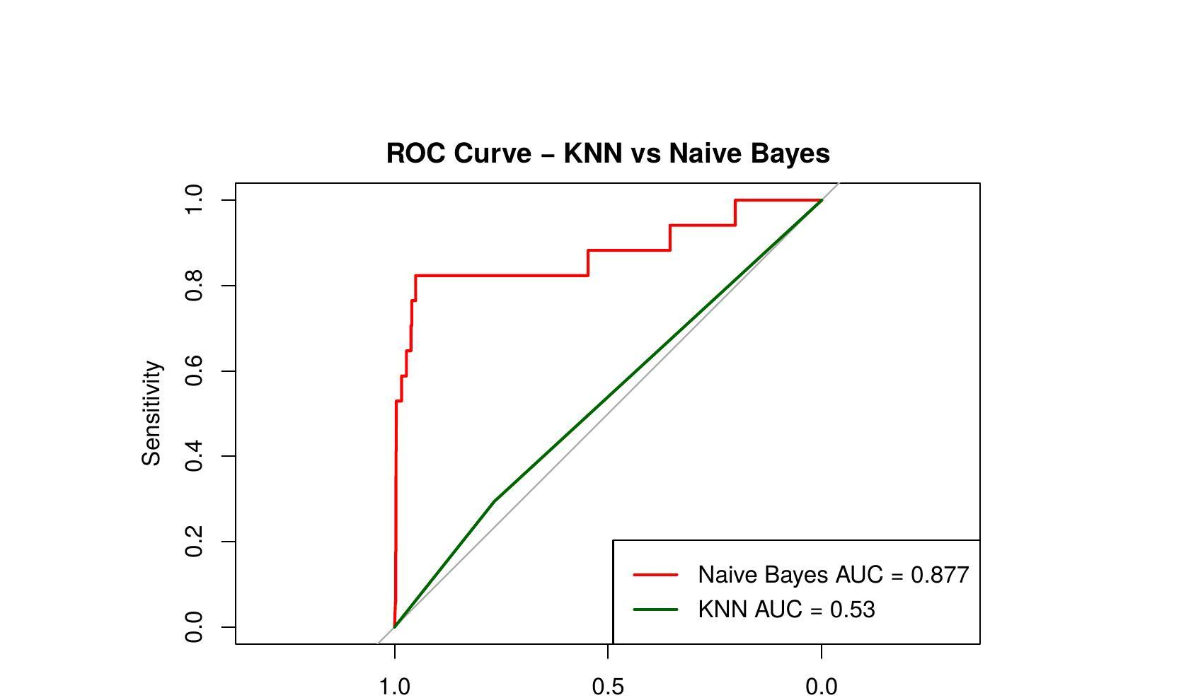

CONCLUSION:
The main purpose of this project was to develop a classification model for detecting fraudulent credit card transactions using K-Nearest Neighbor (KNN) and Naive Bayes. The dataset went through preprocessing steps including transformation, normalization, and class imbalance handling before the models were developed.
Naive Bayes showed much better performance compared to KNN, with an accuracy of 98.13%, sensitivity of 52.94%, specificity of 98.39%, and AUC of 0.877. KNN achieved 59.57% accuracy on the balanced dataset but could only identify 29.41% of the actual fraud cases. The ROC curve analysis further confirmed Naive Bayes as the better model for this problem.
Based on our findings, Naive Bayes is recommended as the more effective model for real-world credit card fraud detection. It handles class imbalance naturally, does not require data balancing, and provides fraud probability scores that banks can use to flag suspicious transactions. It is also recommended that the model be updated regularly as fraud patterns change over time.

REFERENCES:

- Kartik, S. (2020). Credit Card Transactions Fraud Detection Dataset. Kaggle. https://www.kaggle.com/datasets/kartik2112/fraud-detection

- FTC Fraud Statistics: https://www.ftc.gov/reports/consumer-sentinel-network-data-book.

- ML for Fraud Detection: Btoush, E. A. L. M., Zhou, X., Gururajan, R., Chan, K. C., Genrich, R., & Sankaran, P. (2023). A systematic review of literature on credit card cyber fraud detection using machine and deep learning. PeerJ Computer Science. https://www.ncbi.nlm.nih.gov/pmc/articles/PMC10280638/

